Shrimp Stir fry
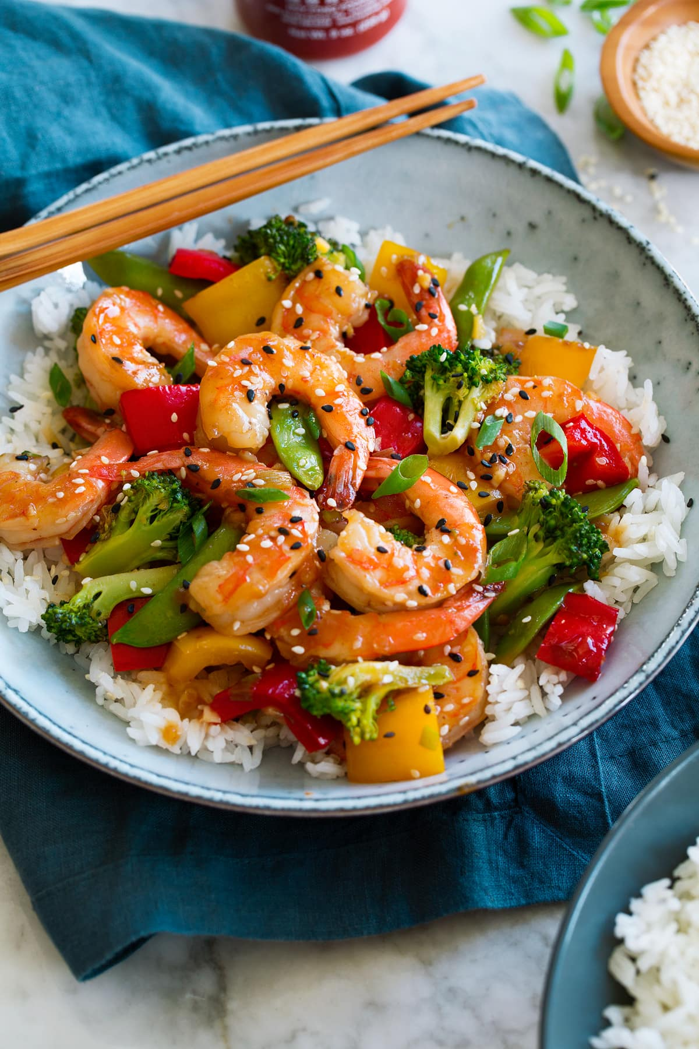
DESCRIPTION:
Shrimp Stir Fry with broccoli florets in a flavorful orange ginger sauce. Healthy and easy, this dish will be on your dinne r table in under 30 minutes!

INGREDIENTS:
1/2 cup orange juice
1 teaspoon orange zest
1 tablespoon + 1 teaspoon ginger minced, divided
1 1/2 teaspoon garlic minced, about 3 average cloves, divided
1 teaspoon maple syrup or honey
1 teaspoon sesame oil
1/8 cup tamari, soy sauce, or braggs
generous pinch of red pepper flakes (optional /to taste)
1 tablespoon cornstarch
10–12 ounces shrimp (raw thawed, peeled and deveined) or use crispy tofu
4 cups broccoli, cut into small florets
3/4 cup red onion, thinly sliced
Serve over jasmine rice.
Garnish with green onions, chili flakes and toasted sesame seeds or slivered almonds.
Cook Mode Prevent your screen from going dark
INSTRUCTIONS:
Whisk together orange juice and zest, 1 tablespoon ginger, 2 garlic cloves, maple syrup, sesame oil, tamari (or soy) red pepper flakes and cornstarch.
Lightly salt shrimp. Heat up a pan add oil to coat the pan, let it warm up to medium high heat. Add shrimp and then add 1 teaspoon ginger and 1/2 teaspoon garlic. Cook the shrimp about 30 seconds on each side remove from pan and set aside.
Add broccoli to the pan with more oil if needed, and stir fry for about 5 minutes add red onion and sauté another 3 minutes. Add the sauce stirring for 1 minute, until it bubbles. Add the shrimp and stir for another minute or until shrimp is done.
Remove from heat and serve with jasmine rice, noodles, brown rice, or whatever you prefer.

NUTRITION:
Serving Size: 1 1/2 cups
Calories: 144Sugar: 6.5 g
Sodium: 596.7 mgFat: 2 g
Saturated Fat: 0.3 g
Carbohydrates: 16 g
Fiber: 3.2 g
Protein: 18.3 g
Cholesterol: 114 mg

